CST-361 Design Patterns in Java
Samantha Krall
Activity 1: UML Diagrams and Tools Install
December 2018
Write Up:
UMLet is a UML tool aimed at providing a fast way of creating UML diagrams. UML elements are modified using text input instead of pop up dialogs. Elements can be modified and used as templates so that users can easily tailor UMLet to their modeling needs. UMLet supports a variety of diagram types: class diagrams, use case diagrams, sequence diagrams, state diagrams, deployment diagrams and activity diagrams. UMLet allows users to create their own custom UML elements. An elements look can be modified at run time by changing a few lines of Java code. UMLet is ope source with a simple user interface, allows you to draw UML diagrams fast, build sequence and activity diagrams from plain text, export diagrams to eps, pdf, jpg, svg and clipboard, share diagrams using Eclipse and create new, custom UML elements. UMLet runs stand alone or as Eclipse plug in on Windows, OS X and Linux.
Customer
name: String
location: String
sendOrder()
receiveOrder()
Deliverables:
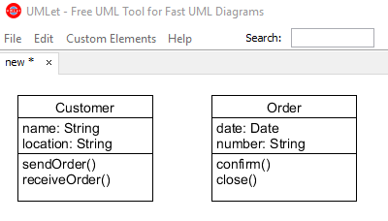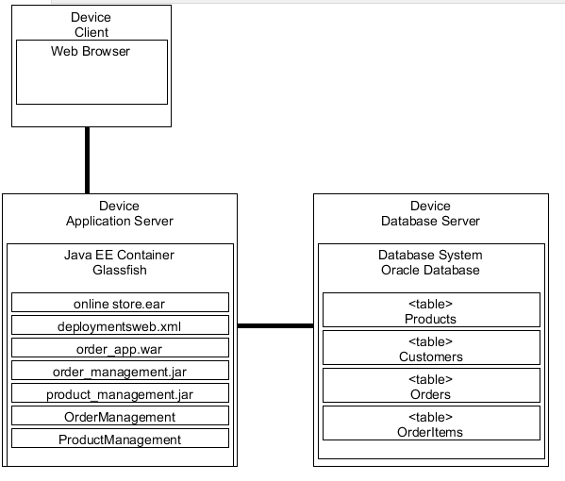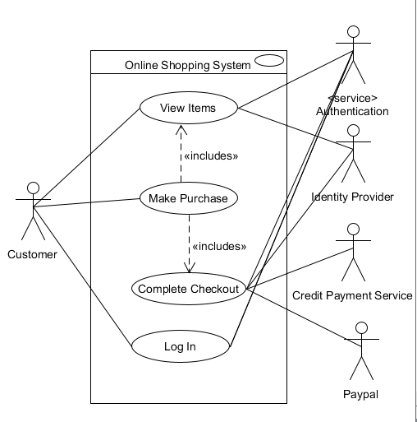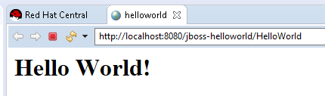
Order
date: Date
number: String
confirm()
close()

